**Liquid Marble Wallpaper in Silver: A Modern Elegance**

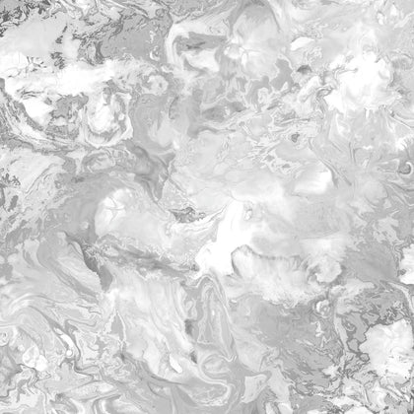Liquid Marble Wallpaper in Silver is a stunning choice for those seeking a contemporary and sophisticated aesthetic in their interiors. Its flowing, marble-like patterns mimic the natural elegance of stone, enhanced by the shimmering silver tones that reflect light beautifully. This wallpaper adds depth and texture to walls, creating a luxurious ambiance that pairs perfectly with minimalist or modern decor themes. Ideal for living rooms, bedrooms, or feature walls, it transforms any space into a stylish haven. Durable and easy to maintain, Liquid Marble Wallpaper in Silver is a timeless option for a chic, high-end look.